LEMUEL OKECHUKWU
VEPH/20B/CY082
TASK : PERSONAL PROJECT

QUESTION 2A — Intercepting and Analyzing Website Traffic (Burp Suite)
Objective:
Use Burp Suite to intercept HTTP/HTTPS traffic, analyse requests/responses, and identify security weaknesses in cookies, headers, and data exposure.
Step-by-Step Solution:
Setup Burp Suite Proxy
1. Environment Setup
- Kali Linux
- Burp Suite Community/Professional on kali Linux
- Browser (Firefox) with Burp Suite proxy configured on kali linux
2. Configure Burp Suite & Browser
- Open Burp Suite and go to the Proxy tab and make sure the interceptor is off
- Go to proxy settings you have the setting configured usually on (127.0.0.1:8080).
- Configure your browser (Firefox) network setting to use Burp as a proxy (HTTP proxy: 127.0.0.1:8080).
- Download and Install Burp's CA certificate if using HTTPS.
3. Visit a website http://juice-shop.herokuapp.com
4. Intercept HTTP/HTTPS Requests and Responses
- In Proxy > Intercept, you’ll see requests like:
- 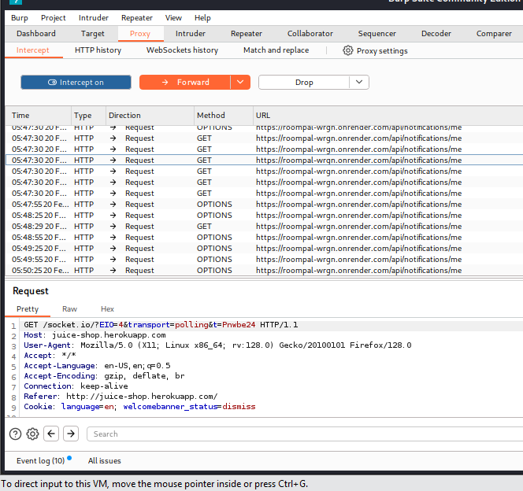
- Click Forward to send to server.
- Response will appear in Intercept or can be viewed in HTTP history.
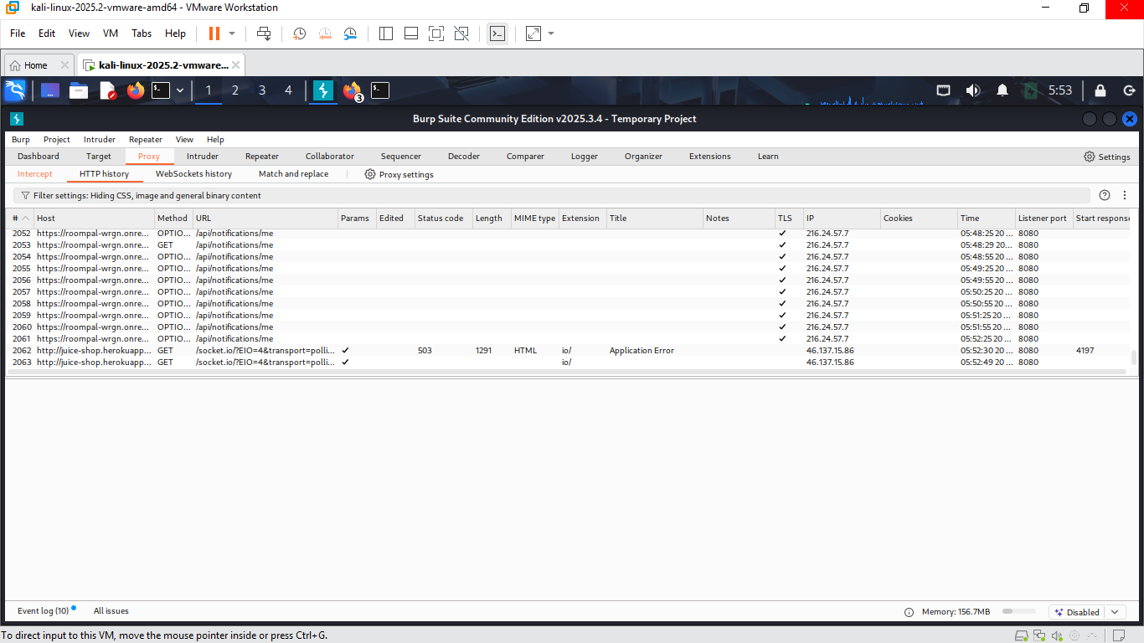
4. Analyse the Following:
A. Cookie Security Flags
- Go to Proxy > HTTP History.
- Find a set cookie header in a response.
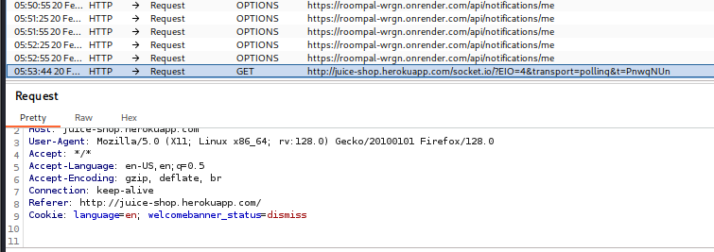
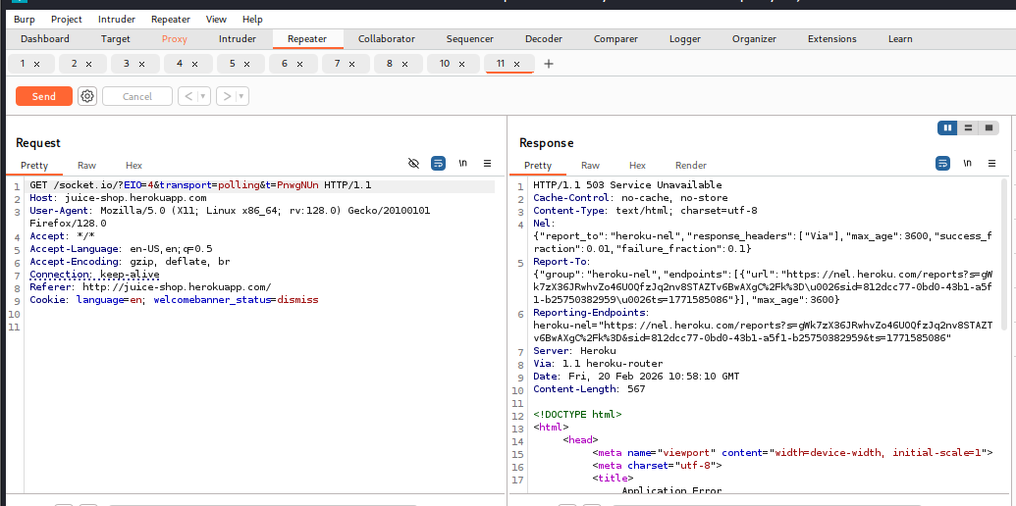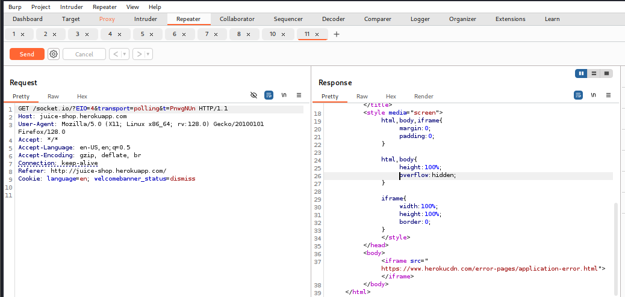
- Observations:
- Repeated identical requests
  - All requests are GET / socket.io/?EID=4&transport=polling&t=proxyunh
  - Same headers, cookies, and query parameters across all entries
- Varying HTTP responses
  - First response: 503 service unavailable – server temporarily unavailable
  - Second response: 200 ok with {“message”:” ok”} – successful JSON response
  - Third response: 404 not found – resource not found
  - Remaining responses: All 200 ok with {“message”:” ok”}
- Indicates intermittent behavior
  - Server may have been unstable or recovering during the requests
  - Could be due to cold starts (Heroku free tier), temporary routing issues, or backend crashes/restarts
- Socket.IO polling
  - The request is part of socket.IO ‘s long-polling fallback mechanism
  - EID=4 likely refers to an engine.io session ID or packet type
  - t=proxyunh is a cache-busting timestamp parameter
- No actual socket.IO data exchange
  - Responses only contain {“message”:”ok”}, not actual socket.IO payloads
  - Suggests handshake or heartbeat requests rather than real-time events
Interpretation:
This log shows intermittent server behavior for a socket.IO polling request. The first few attempts failed (503, 404), but subsequent ones succeeded. This could indicate:
- Server was starting up or recovering
- Load balancer or routing issues
- Temporary misconfiguration or downtime
B. Presence or Absence of HTTPS
- Check the URL scheme in requests.
- If site uses HTTP → No encryption → Traffic visible in clear text.
- If HTTPS but certificate invalid/mixed content → Still risky.
C. Security Headers
- In response headers, check for:
D. Sensitive Information in Requests/Responses
- Look for:
  - Passwords in URL (GET request)
  - Credit card numbers
  - Session tokens in URL
  - Internal IPs or stack traces in responses

QUESTION 2B — Identifying Website Security Weaknesses
Objective:
Use, Burp suite to find at least one security weakness from the list:
- Missing security headers
- Insecure cookies
- Information disclosure
- Weak authentication behaviour
- Input handling weaknesses
Step-by-Step Solution
- Enter URL - http://juice-shop.herokuapp.com
- Check for input handling weaknesses:
  - Go to Proxy > HTTP history.
  - Find a parameter (e.g., id=1, search=test).
  - Send to Repeater.
  - Test with payloads like ‘or “and observe errors.
- Identify weakness:
  - If error reveals SQL syntax → SQL Injection possible.
  - If error shows full path → Information disclosure.
- Check authentication behaviour:
  - Look for login requests.
  - Check if failed login gives different response times → possible username enumeration.
Analysis:
Weakness Identified: The application sets cookies without essential security flags (secure flag, httponly flag, samesite flag), making them vulnerable to interception via network sniffing and theft via Cross-Site Scripting (XSS) attacks.
Why this is a weakness:
- Without secure flag → Cookies transmitted over unencrypted HTTP
- Without httponly flag → JavaScript can access cookies
- Without samesite flag → Vulnerable to CSRF attacks
Risk:
- Session hijacking
- Account takeover
- Privacy breach
Evidence:
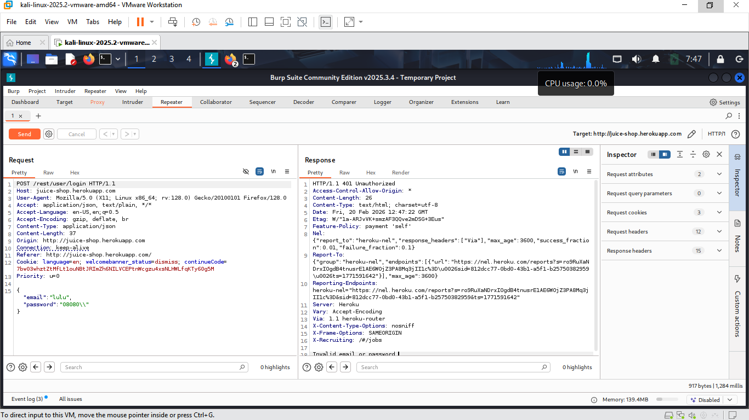

QUESTION 2C — Network and Log Visibility
Objective:
Demonstrate defensive awareness by choosing Wireshark explaining:
- What security is visible
- What penetration testing would look like
- What is happening if critical
Wireshark (Traffic Analysis)
What security is visible:
- Unencrypted traffic (HTTP, FTP, Telnet) — credentials visible.
- DNS queries — reveals sites visited.
- TCP handshakes — reveals connections.
- Malformed packets — possible scanning/attack.
- ARP traffic — possible spoofing.
What penetration testing would look like:
- Port scanning (e.g., SYN flood from one IP).
- Brute force attempts (many failed login packets).
- SQL injection attempts (unusual SQL keywords in HTTP payload).
- Directory brute force (many 404 responses).
What is happening if critical:
- Example: Sudden spike in SYN packets from one IP → possible DDoS or port scan.
- Example: Repeated login POST requests → brute force attack.
- Example: Large outbound data transfer → data exfiltration.
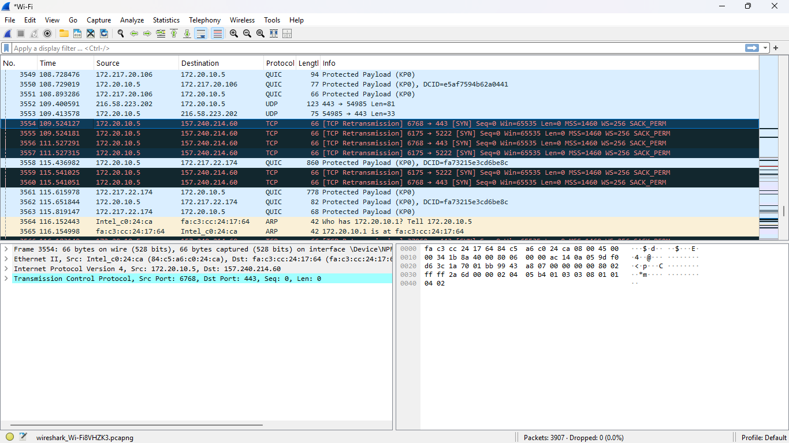
Security visible: Unencrypted HTTP traffic reveals session cookies and login credentials in plaintext. This is a major risk on public networks.
Penetration testing would look like: An attacker would first perform a SYN scan (visible as many TCP SYN packets to different ports), then send crafted HTTP requests with SQLi payloads (visible in packet payloads as ‘ or ‘1’=’1’, and finally attempt to steal cookies (visible in HTTP headers).
Critical event: If I see a sudden burst of TCP SYN packets from a single IP to multiple ports, that indicates a port scan — the first step of an attack. If followed by HTTP requests with SQL syntax, it's likely an active exploitation attempt.

SECTION 3: System Operations and Security Governance
Question 3A: System Interaction Using Kali Linux
Virtual Machine Installation and Kali Integration
Introduction to Virtualization:
Virtual machines (VMs) provide isolated environments for running operating systems without affecting host systems. This is essential for security testing as it contains potentially harmful activities and enables snapshot-based recovery.
VM Installation Process (300+ words):
Installing a virtual machine requires understanding virtualization concepts and resource allocation. VirtualBox, an open-source hypervisor, provides cross-platform compatibility for running multiple operating systems simultaneously.
The installation begins with downloading VirtualBox from the official Oracle website. After installation, creating a new VM involves allocating system resources - typically 4GB RAM and 50GB dynamic storage for Kali Linux. The VM configuration must match the guest OS requirements; Kali Linux recommends 2GB minimum RAM but performs better with 4GB.
Network configuration is critical for security testing. Network Address Translation (NAT) allows internet access while isolating the VM from the host network. Bridged networking provides direct network access, useful for certain testing scenarios but riskier for host security.
Kali Linux Integration: Kali Linux, the industry standard for penetration testing, integrates with VirtualBox through ISO installation files downloaded from the official Kali website. The integration process involves:
- Downloading the Kali Linux ISO image
- Mounting the ISO to the VM's virtual DVD drive
- Booting the VM and following the installation wizard
- Installing VirtualBox Guest Additions for enhanced functionality
Guest Additions enable seamless mouse integration, shared folders, and better video performance. This integration transforms the isolated VM into a productive testing environment while maintaining security boundaries.
The Kali environment comes pre-loaded with 600+ penetration testing tools categorized by function - information gathering, vulnerability analysis, web applications, password attacks, and exploitation tools. This comprehensive toolkit makes Kali indispensable for security professionals.
Practical System Operations in Kali
1. Directory Creation:
- Command: mkdir
- Syntax: mkdir <directoryname>.
Purpose: This creates a directory in the current working directory
2. File Creation and Population:
Creating an Empty File
Command: touch
Syntax: touch <filename>.txt
Purpose: Creates an empty file.
- Creates a File with Specified Content (Country List)
Command: nano
Syntax:
- nano < filename >
- (Appends list of countries)
- Save and Enter
Purpose: Creates a file with specified content or appends to an existing file.

3. File Permission Modification:
Command: chmod
Purpose: This is to modify files permission.
For example:
To modify the file permissions so that
- the owner has read and write access (rw)
- the group has read, write, and execute permissions (rwx)
- others have read-only access (r)
read is 4, write is 2 and execute is 1
Hence, the permission pattern we will be:
- Owner: read (4) + write (2) = 6
- Group: read (4) + write (2) + execute (1) = 7
- Others: read (4) = 4
So, the numeric permission value is 674 (6 for owner, 7 for group, 4 for others)

Question 3B: Website Hardening Recommendations
Based on Section 1 findings, here are practical hardening measures:
Issue | Hardening Recommendation | Priority
Missing HTTPS | Install SSL certificate and enforce HTTPS redirect | HIGH
Apache 2.2.14 | Upgrade to Apache 2.4.x or latest stable | HIGH
PHP 5.3.2 | Upgrade to PHP 7.4 or 8.x | HIGH
PHP Version Disclosure | Set expose_php = off in php.ini | MEDIUM
Missing Security Headers | Add headers in Apache config:  Header set x- frame-options “SAMEORIGIN”  Header set x-content-type-options “nosniff”  Header set content-security-policy “default-src” ‘self” | MEDIUM
Information Leakage | Disable server signature: servertokens prod and serversignature off | MEDIUM
HTTPS Implementation Steps:
- Obtain SSL certificate (Let's Encrypt provides free certificates)
- Configure Apache with SSL virtual host
- Implement redirect from HTTP to HTTPS
- Update HSTS headers to enforce HTTPS
Question 3C: Security Policy Design
Password Policy
Purpose: Protect user accounts from unauthorized access through strong authentication.
Requirements:
- Minimum 12 characters length
- Must contain uppercase, lowercase, numbers, and special characters
- Password history: 10 previous passwords cannot be reused
- Maximum age: 90 days, minimum age: 1 day
- Account lockout after 5 failed attempts for 30 minutes
Alignment with CIA:
- Confidentiality: Strong passwords prevent unauthorized access
- Integrity: Protected accounts prevent unauthorized data modification
- Availability: Lockout policies prevent brute-force attacks consuming system resources
Acceptable Use Policy
Purpose: Define proper system usage and prohibited activities.
Permitted Use:
- Business-related activities only
- Access during work hours for authorized purposes
- Company-issued devices for official communication
Prohibited Activities:
- Sharing credentials or accessing others' accounts
- Installing unauthorized software
- Accessing inappropriate content
- Bypassing security controls
Enforcement:
- Violations result in disciplinary action up to termination
- Activity monitoring for compliance verification
Incident Reporting Policy
Purpose: Ensure timely response to security incidents minimizing damage.
Incident Definition:
- Unauthorized system access
- Malware infections
- Data breaches or leaks
- Denial of service attacks
- Physical security breaches
Reporting Procedure:
- Immediate notification to IT Security within 1 hour
- Documentation of incident details (what, when, how discovered)
- Preservation of evidence (logs, screenshots)
- No discussion outside authorized channels
Response Timeline:
- Initial triage: 2 hours
- Containment: 24 hours
- Investigation: 5 business days
- Remediation: Based on severity
Question 3D: Quantitative Risk Analysis
Selected Asset: Customer Database on Web Server
Asset Valuation
The customer database contains 5,000 customer records. Using quantitative risk analysis methodology:
- Value per customer record: $150 (GDPR fines average €150-200 per record)
- Total Asset Value: 5,000 × $150 = $750,000
Risk Calculation Parameters
Threat Scenario: SQL injection leading to database breach
Parameter | Value | Justification
Exposure Factor (EF) | 80% (0.8) | Typical breach exposes 80% of records
Annual Rate of Occurrence (ARO) | 0.5 | Once every 2 years based on industry statistics
Single Loss Expectancy (SLE) | $600,000 | SLE = Asset Value × EF ($750,000 × 0.8)
Annual Loss Expectancy (ALE) | $300,000 | ALE = SLE × ARO ($600,000 × 0.5)
Risk Calculation Formulas
SLE = Asset Value × EF
- $750,000 × 0.8 = $600,000
ALE = SLE × ARO
- $600,000 × 0.5 = $300,000
Security Investment Decision
The ALE of $300,000 represents the annual expected loss from this risk. Security investments should be justified against this figure:
Cost-Benefit Analysis:
Security Control | Cost | Risk Reduction | New ALE | ROI
WAF Implementation | $20,000/year | 70% | $90,000 | $190,000 savings
Security Code Audit | $15,000 | 50% | $150,000 | $135,000 savings
Penetration Testing | $10,000/year | 30% | $210,000 | $80,000 savings
Decision: Implement WAF and conduct security code audit for maximum risk reduction ($20,000 + $15,000 = $35,000 investment saves $300,000 - $90,000 = $210,000 annually).

